Resolution proof method

Resolution method for propositional logic
Resolution, as a syntactic proof method, is introduced by the formal (axiomatic) system:
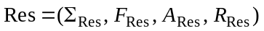as was proposed in paper:
- 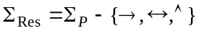 is the alphabet;
- 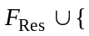□ is the set of well-formed formulas;
- 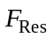 is the set of all clauses built using the alphabet 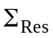;
- □ is the empty clause which does not contain any literal and it symbolizes inconsistency;
- 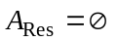 is the set of axioms ;
- 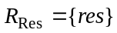 is the set of inference rules containing the resolution rule (res): 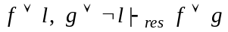, where is a literal and 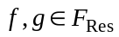.

The clauses 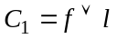 and 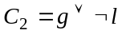 ( is a literal and ) are called clashing clauses and they resolve upon the literal . We use the notation: 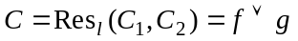, where 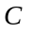 is called the resolvent of the parent clauses 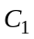 and 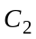.

If 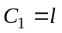 and 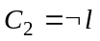, 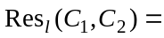□ (empty clause) which is inconsistent.

Graphical representation:

□

Resolution as an inference rule is a generalization of the rules: modus ponens, modus tollens and the syllogism rule.

Algorithm propositional_resolution:
input: – a set of propositional clauses
output: message “ is consistent” or “ is inconsistent”
begin
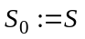; 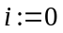;
do
choose two clashing clauses: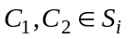;
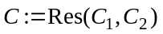; 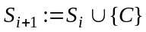;
if (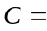□) then write ” is inconsistent”; exit;
else 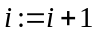;
end_if
until (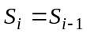 ) // no new clauses can be derived
write “ is consistent”;
end
          - Soundness theorem
If the empty clause is derived from the set of propositional clauses using the resolution algorithm (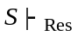□), then is an inconsistent set.
          - Completeness theorem
If the set of propositional clauses is inconsistent, then the empty clause can be derived from using the resolution algorithm (□).
          - Soundness and completeness theorem
A set of propositional clauses is inconsistent if and only if 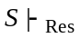□.

A propositional formula 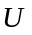 is a theorem (tautology) if and only if the empty clause can be derived from the conjunctive normal form of 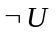, using the resolution algorithm.
is a theorem (tautology) if and only if 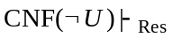□.

Let 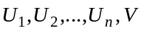 be propositional formulas.
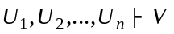 if and only if 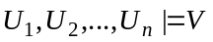if and only if
□.
The following theorem, inspired from Davis-Putman procedure [15], introduces a set of transformations used to simplify an initial set of clauses, preserving its consistency/inconsistency.

A set of propositional clauses can be simplified, preserving its consistency/inconsistency, by applying the following transformations:
- Delete the clauses that are tautologies because they are not useful in the derivation of the empty clause (from true we cannot derive false).
- Delete the clauses subsumed by other clauses of .
is subsumed by and subsumes if there exists a clause 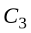 such that 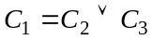.
- Delete every clause that contains a pure literal.
A pure literal in the set of clauses is a literal that appears in a clause of , but its negation does not appear in any clause
of .
- Let 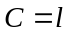 be a unit clause of . Delete every clause containing and delete 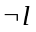 from every remaining clause.

Remarks:
- If  is obtained by applying all the above transformations on a set of clauses, then is a consistent set.
- If the empty clause (□) is obtained by applying all the above transformations on a set of clauses then is inconsistent.

Strategies for propositional resolution

- The level saturation strategy [52] generates levels of resolvents corresponding to the exploration of the whole search space which contains all the possible resolvents.

Algorithm level-saturation-strategy:
input: - the initial set of clauses;
output: message “ is inconsistent” or “ is consistent”
begin
// we generate the sequence 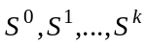 containing sets of clauses (levels)
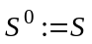; 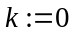; // initial level
do
{ 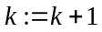; ;
// we eliminate the resolvents obtained in the current level but which appear already in the previous levels
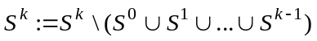;
} until (□ 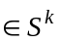 or 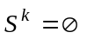).
if (□ 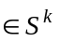) then write “ is inconsistent”
else //no more resolvents can be derived and □ 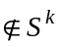
write ” is consistent”
end_if
end

- The deletion strategy [15]: the resolvents that are tautologies or are subsumed by other clauses in the set of clauses are eliminated and they will not be used further in the resolution process because they produce redundant clauses.

- The set-of-support strategy [65] avoids resolving two clauses belonging to a consistent subset of the initial set of clauses, because the resolvents derived from a consistent set are irrelevant in the process of deriving □ (inconsistency).
Let be a set of clauses. A subset of is called the support set of , if the set 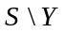 is consistent. The set-of-support resolution is the resolution of two clauses that are not both from the set . The resolvents generated during the resolution process are added to .

In order to make the resolution process more efficient, the refinements of resolution (lock resolution, linear resolution, semantic resolution) impose restrictions on the clashing clauses.

Lock resolution
- Each occurrence of a literal from a set of clauses is arbitrarily indexed with an integer.
- Restriction: the literals resolved upon must have the lowest indices in their clauses.
- The literals from resolvents inherit the indices from their parent clauses. If the parent clauses have a common literal, in the resolvent this literal will have the lowest index from the inherited indices.
- At the implementation level we must combine lock resolution with the level saturation strategy in order to check all the possible ways of deriving □.
          - Soundness
Let be a set of clauses having each literal arbitrarily indexed with an integer. If from the empty clause can be derived using lock resolution (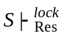□), then is inconsistent.
          - Completeness
Let be a set of clauses having each literal arbitrarily indexed with an integer. If is inconsistent, then there is a lock derivation of the empty clause from (□).
The completeness property is not preserved if lock resolution is combined with the deletion strategy or with the set-of-support strategy.

Linear resolution

The resolution process is a linear one: at each step one of the parent clauses is the resolvent derived at the previous step.
For a set S of clauses, a linear deduction of 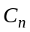 from S with 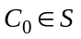 as the top clause is symbolized graphically as follows:
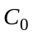 is the top clause
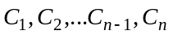 are central clauses
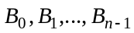 are side clauses

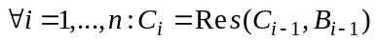

          - Soundness and completeness
The set of clauses is inconsistent if and only if 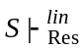□.

We can combine the linear resolution with the deletion strategy and the completeness property is preserved.

This refinement of resolution also provides a strategy at the implementation level: backtracking algorithm. At each iteration, for the current central clause there are more possible side clauses. We continue the resolution process choosing one side clause. If at the iteration ‘’ the process is blocked (the central clause 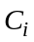 is a tautology or it is an existing central clause: 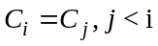, or does not have side clauses) or all the side clauses of were used, then we go back to the previous iteration (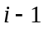) and we choose another possible side clause for 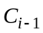 to continue the resolution process.

The algorithm stops in two cases:
- the empty clause was derived and the conclusion is that is inconsistent.
- for the top clause all the possible side clauses were used, but the empty clause was not derived, then we conclude that the set is consistent.
The consistency of a set of clauses is proved after a complete search without the derivation of the empty clause.

Special cases of linear resolution:
- unit resolution: the central clauses have at least a unit clause as a parent clause.
- input resolution: all side clauses are initial (input) clauses.

The equivalence of unit resolution and input resolution is expressed by the following theorem.

Let be a set of propositional clauses. 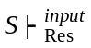□ if and only if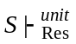□.

These two refinements of resolution are sound, but they are not complete:
soundness: If 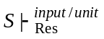□ then is inconsistent;
incompleteness: there exist inconsistent sets of clauses from which □ cannot be derived using input or unit resolution.

A clause is called a positive clause if it contains only positive literals. A clause is called a negative clause if it contains only negative literals. A clause is called Horn clause if it contains exactly one positive literal, all the other literals are negative.

The input resolution is complete on a set of Horn clauses with a negative top clause. (PROLOG).

            - knowledge base
From the hypotheses:
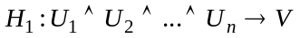
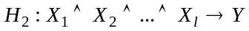
…
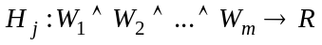
is 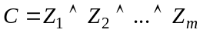 deducible?
To prove by refutation using resolution we have to transform into clausal normal forms the hypotheses and the negation of the conclusion.

A formula of type: 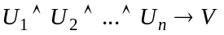 provides a Horn clause:
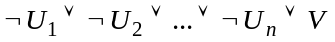
The hypothesis 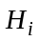 provides the Horn clause 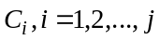.
The negation of  is 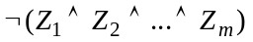and provides a negative clause:
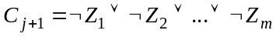
We have to apply the input resolution to the set 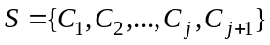with the top clause 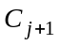.
According to Theorem 5.1 we have that: 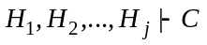if and only if 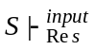 □.

Resolution in first-order (predicate) logic
We present the predicate resolution as a formal (axiomatic) system according to the approach from paper:
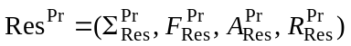, where:
- 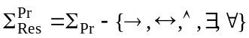 is the alphabet;
- {□} is the set of well- formed formulas;
- 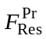 is the set of all clauses built using the alphabet 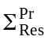;
- □ is empty clause;
- 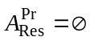 is the set of axioms;
- 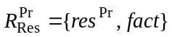 is the set of inference rules containing the resolution rule (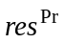) and the factoring rule (fact).
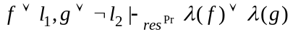, where 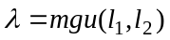, 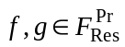.
where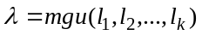

The predicate clauses 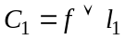 and 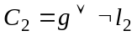, without common free variables, are called clashing clauses if the literals and are unifiable: there exists 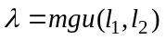.
The binary resolvent of 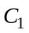 and 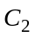 is 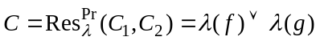.
If 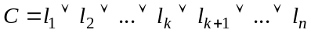; 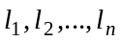-literals and 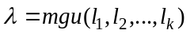
is called a factor of .

These two inference rules are combined and the definition of a predicate resolvent is obtained.

The predicate resolvent of two parent clauses and is one of the following:
- the binary resolvent of and ;
- the binary resolvent of and a factor of ;
- the binary resolvent of a factor of and ;
- the binary resolvent of a factor of and a factor of .

Let 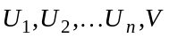 be first-order formulas.
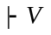 (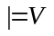) if and only if 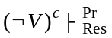□.
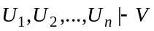 if and only if 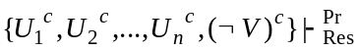□.

All the refinements and strategies of resolution in propositional logic can be used in predicate logic. It is recommended to rename the free variables in the initial set of predicate clauses, such that they will be distinct in different clauses.

Algorithm predicate_ resolution:
input: - first-order formulas.
output: message: ”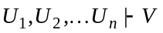” or „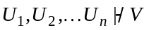” or
“we cannot decide if or ”
begin
build the set of clauses: 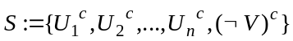;
do{
select 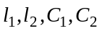 such that:
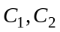 are clauses or factors of clauses of ;
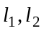 are literals, 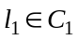, and 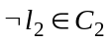;
if ( and are unifiable with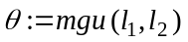) then
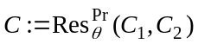;
if (=□) then write “”; exit;
else 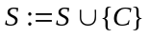;
end_if
end_if
}until (no new resolvents can be derived or a predefined quantity of effort was
done)
if (no new resolvents can be derived) then write ” ”;
else write ”we cannot decide if or ”
end_if
end
The resolution algorithm for predicate logic is a semi-decision procedure.
          - (Church 1936)
The problem of validity of a first-order formula is undecidable, but it is semi-decidable. If a procedure Proc is used to check the validity of a first-order formula we have the following cases:
- if the formula is valid, then Proc ends with the corresponding answer.
- if the formula is not valid, then Proc ends with the corresponding answer or Proc may never stop.

